**Table of content**

**Abstract**  2

Chapter 1:Introduction 3-4

1.1 overview of the project

1.2 aims and objectives of gym management system

Chapter 2:Theoretical Background 5-6

2.1 system study

2.2 existing system

2.3 proposed system

Chapter 3:Software and Hardware requirement 7

3.1 software requirements

3.2 hardware requirements

Chapter 4:System Design 8-11

4.1 schema diagram

4.2 ER diagram

4.3 data base tables

Chapter 5:Snapshots 12-18

5.1 snapshots

Chapter 6:Conclusion 19

6.1 conclusion

Chapter 7:Future Enhancement 20

7.1 future works

Chapter 8:Bibliography 21

8.1 sites

8.2 books

**ABSTRACT**

Any business that does not have a website is missing out on one of the most powerful marketing tools available to them. The main reason that it is important for businesses to have a website is how people are likely to find you. These days most people will go online and research products and companies before they make a purchase. For this reason of dependency on online, we develop a website for a gymnasium in which customer can get all information about the gymnasium and he/she can access or enroll at the gym via online. Usually, the client uses MS Excel or paper, and maintains their records, however it is not possible them to share the data from multiple system in multi user environment, there is lot of duplicate work, and chance of mistake. When the records are changed they need to update each and every excel file. The Smart Gym Management System eliminates most of the limitations of the existing software. Increasing efficiency and effectiveness, automation, accuracy, user-friendly interface, information availability, communication capacity, maintenance, cost reduction makes our system smarter than the existing system.

**Chapter 1**

**Introduction**

We all know health is a wealth. We do not need a fancy car, big apartment, a doctor degree without a health. Being healthy is a first thing we need to keep in mind. Because most of time our attitude depends on how we feel. Being healthy and fit gives us energy to do anything. Physical fitness is very necessary for a healthy and tension free life. Physical fitness includes diet, exercise and sleep. These three basic things have their own importance in each individual's life and everyone should be sensible with regard to these for a healthy life.

**1.1** **Overview Of The Project**

The “Gym management system” is for those who do a gym business. Before doing anything we did a decent research on major difficulties for gym owners. We examined carefully about how to make a huge registering system without failure as well as different function for different kind of user depending on their privilege.

Gym is the best way to get fitness and healthy life. There are more facility in gym that members get satisfied by there money and time. The trainer of the gym will take the responsible of the members to train. Gym admin work is to provide the tool which they required and the payment for the trainer.

Gym management system holds the detailed information of the members and membership system. Gym management provides lots of functions such as registration of member, payment method, payment package, trainer details, tool requirement and so on. The admin of the gym will be responsibility of the whole gym management. There should be good communication between the members and gym master of the gym. This are helps to provide good quality of services to customer from gym admin.

This management system is become very simple to understand because of data flow diagram provided by us. Context level diagram and some chart are also available in this case study. The demo of using the software such as customer detail from, data base of software is also provided by us.

The gym management system aim is to provide good service for the customer, best facilities to satisfy the customer, provide total information about machine and data of coaches is also stored in it. Services provided by gym are also handled by the system. There is a good security for the details provided by the member in gym management system.

**1.2 Aim And 0bjectives Of The Gym Management System:**

* The main objective of the projective is to develop software that facilities for the data storage, data maintenance and its retrieval for the gym in an igneous way.
* To store the record of the customers, the staff that has the privileges to access, modify and delete any record and finally the service, gym provides to its customers.
* Also only staff has the privilege to access any database and make the required changes, if necessary.
* To develop easy-to-use software which handles the customer-staf relationship in an effective manner.
* To develop a user-friendly system that requires minimal user training. Most of the features and function are similar to those on any windows platform.
* Secured data storage for authority end.
* Secure the user ends data by providing each user’s own personal credentials.
* To provide better graphical user interface.
* Computerization can be helpful as means of saving time and money.

**Chapter 2**

**Theoretical Background**

We have done a project on Gym Management and database management and transactions. This system is proposed to be an automate database management & transactions. This stores employee, member, payroll, receipts, and products information. It also provides the facility of search & advanced search for searching the records efficiently & immediately. This system provides data storing & report generation with graphical user interface (GUI).

**2.1 System Study**

There are two types of system to study existing system and proposed system. It is always necessary to study and recognize the problems of existing system, which will help in finding out the requirements for the new system. System study helps in finding different alternatives for better solution.

**2.2 Existing System**

An Existing system refers to the system that is being followed till now. The gym is working manually. The current system is time consuming and also it is very costly, because it involves a lot of paperwork. To manually handle the system was very difficult task. But now-a-days computerization made easy to work.

Disadvantages of existing system:-

* To increase efficiency with reduced cost.
* To reduce the burden of paper work.
* To save time management for recording details of each and every member and employee.
* To generate required reports easily.
* Lack of security of data.
* More man power.
* Time consuming.
* Consumes large volume of pare work.
* Needs manual calculations.
* Direct role the higher officials.

**2.3 Proposed System**

The online gym management system is user-friendly application. This automated system makes all functionality easier for both owners and customers. It is very simple in design and to implement. The system requirements are very low. System resources and the system will work in almost all configurations.

The aim of proposed system is to develop a system of improved facilities. The proposed system can overcome all the limitations of the existing system. The system provides proper security and reduces the manual work.

* Security of data.
* Ensure data accuracy’s.
* Proper control of the higher officials.
* Minimize manual data entry.
* Minimum time needed for the various processing.
* Greater efficiency.
* Better service.
* User friendliness and interactive.
* Minimum time required.
* Reduces the cost of maintenance.

**Chapter 3**

**Software And Hardware Requirements**

**3.1 Software requirements :**

The software requirement which is use to perform the gym management system

* Operating System:- Windows,Lunix,Mac os
* Programming Language:- PHP
* User Interface:- HTML,CSS
* Database:- MYSQL
* Server Developmnet :- XAMPP
* Browser:- Google chrome

**3.2 Hardware requirement :**

The hardware components which are used in gym management system

* Processor :- Celeron or above
* Windows:- Windows 7 or higher
* RAM:-2 GB
* Hard disk:-100 GB(Recomended)

**Chapter 4**

**System Design**

**4.1 Schema Diagram:**

ADMIN

Admin_id Admin_name Admin_pass

DAYS

Days_id Day_name

EXERCISE

Exer_id Exer_name Exer_image Sets Day_id User_id

TRAINER

Tran_id Tran_name Tran_class Tran_contact

USER

User_id User_name User_email User_pass User_weight User_age ser_contact

**4.2 ER Diagram:**

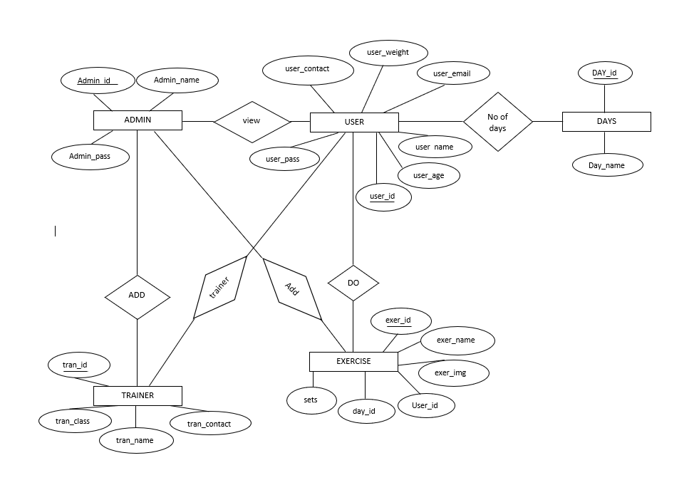

**4.3 Data Base Tables :**

**Admin :**

|  |  |  |
| --- | --- | --- |
| **Attributes** | **Datatype** | **Description** |
| Admin_id | varchar | It is an attribute use to specify admin_id. |
| Admin_email | varchar | It is an attribute use to specify email_id of admin |
| Admin_pass | integer | It is an integer use to specify admin pass |

**Days :**

|  |  |  |
| --- | --- | --- |
| **Attributes** | **Datatypes** | **Description** |
| Day_id | varchar | It is an attribute use to specify days_id |
| Day_name | Varchar | It is an attribute use to specify name of the day |

**Exercise :**

|  |  |  |
| --- | --- | --- |
| **Attributes** | **Datatypes** | **Description** |
| Exer_id | Varchar | It is an attribute use to specify exercise_id |
| Exer_name | Varchar | It is an attribute use to specify name of the exercise |
| Sets | Varchar | It is an attribute use to specify exercise sets |
| Day_id | Varchar | It is an attribute use to specify day_id |
| Exer_img | Varchar | It is an attribute use to specify image of the exercise |
| User_id | Varchar | It is an attribute use to specify user_id |

**Trainer :**

|  |  |  |
| --- | --- | --- |
| **Attributes** | **Datatypes** | **Description** |
| Tran_id | varchar | It is an attribute use to specify trainer_id |
| Tran_name | varchar | It is an attribute use to specify name of the trainer |
| Tran_class | varchar | It is an attribute use to specify trainer_class |
| Tran_contact | integer | It is an integer use to specify contact number of trainer |

**Users :**

|  |  |  |
| --- | --- | --- |
| **Attributes** | **Datatypes** | **Description** |
| User_id | varchar | It is an attribute use to specify user_id |
| User_name | varchar | It is an attribute use to specify name of the user |
| User_email | varchar | It is an integer use to specify email_id of the user |
| User_pass | integer | It is an attribute use to specify user_pass |
| User_weight | integer | It is an attribute use to specify weight of the user |
| User_age | integer | It is an attribute use to specify age of user |
| User_contact | integer | It is an attribute use to specify contact number of the user |

**Chapter 5**

**Snapshots**

Gym management system is very useful for the people who like be fit and healthy. For that we use to make them bit comfort by handling online registration system for the customer by this they feel safe of there information provided. Now we get to know about how the gym management system work online in the system. We have some screenshot of the gym management system how it works. Lets see below we have screenshots.

**Admin Login :**

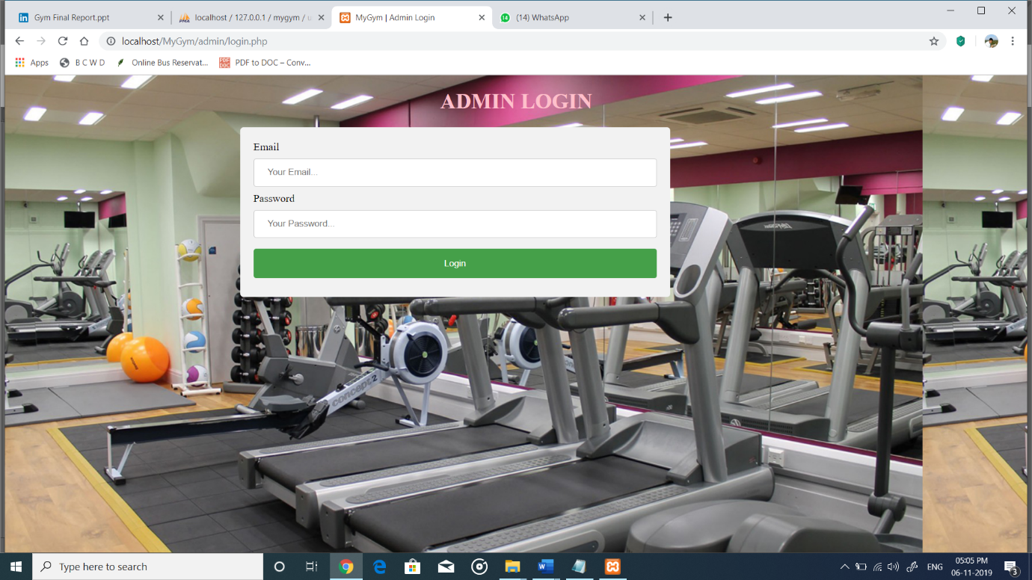

This is the first screenshot of the gym management system. In this we get to see admin login page, which is only for admin. He can only login to this page, for that he should require his email_id and password. After filling this he can click to login and get logged in it.

**Admin Pannel** :

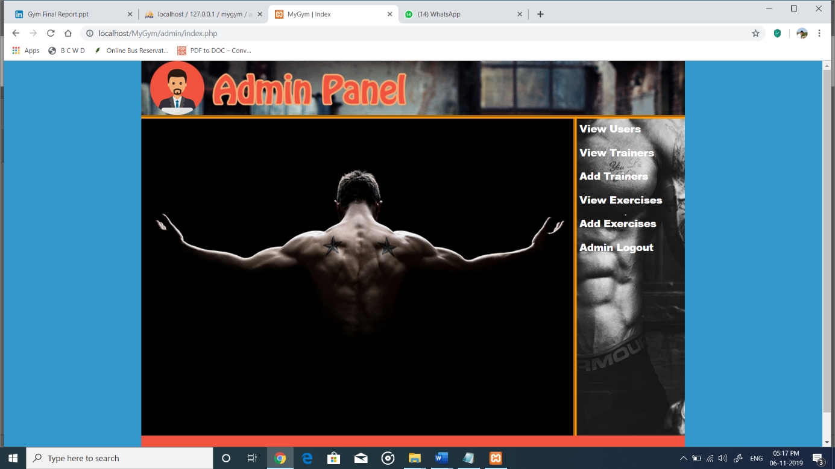

This is the screenshot of the main admin panel. After login to the account this page will get to see. in this we can see some options for the admin to know. There are options like view users, view trainers, add trainers, view exercises, add exercises, admin logout

**Admin View All Users:**

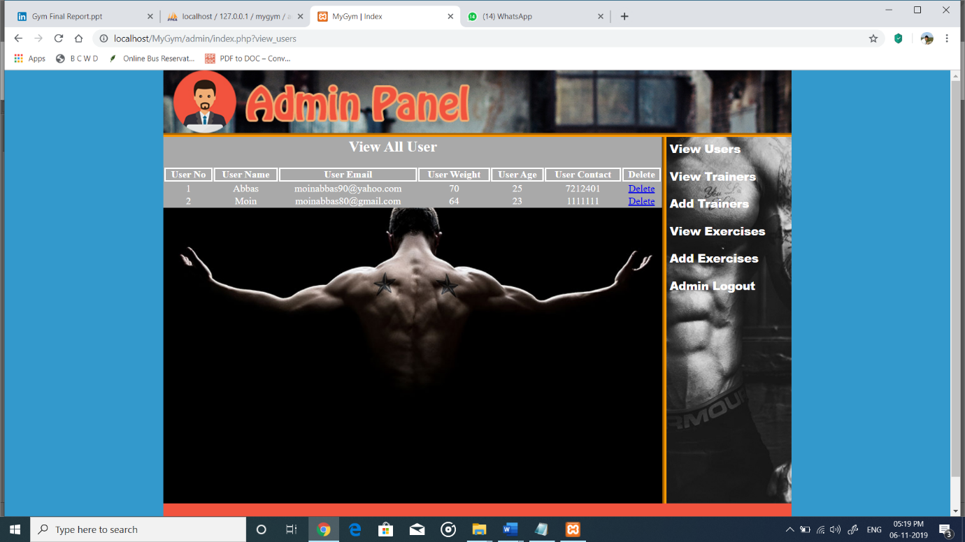

This is the screenshot of the option view user. By this option we can get to see details of the user. And for entity view user we have a attributes of user_no, user_name, user_email, user_weight, user_age, user_contact, delete. This attributes use to specify details of the user.

**Admin view all Trainers :**

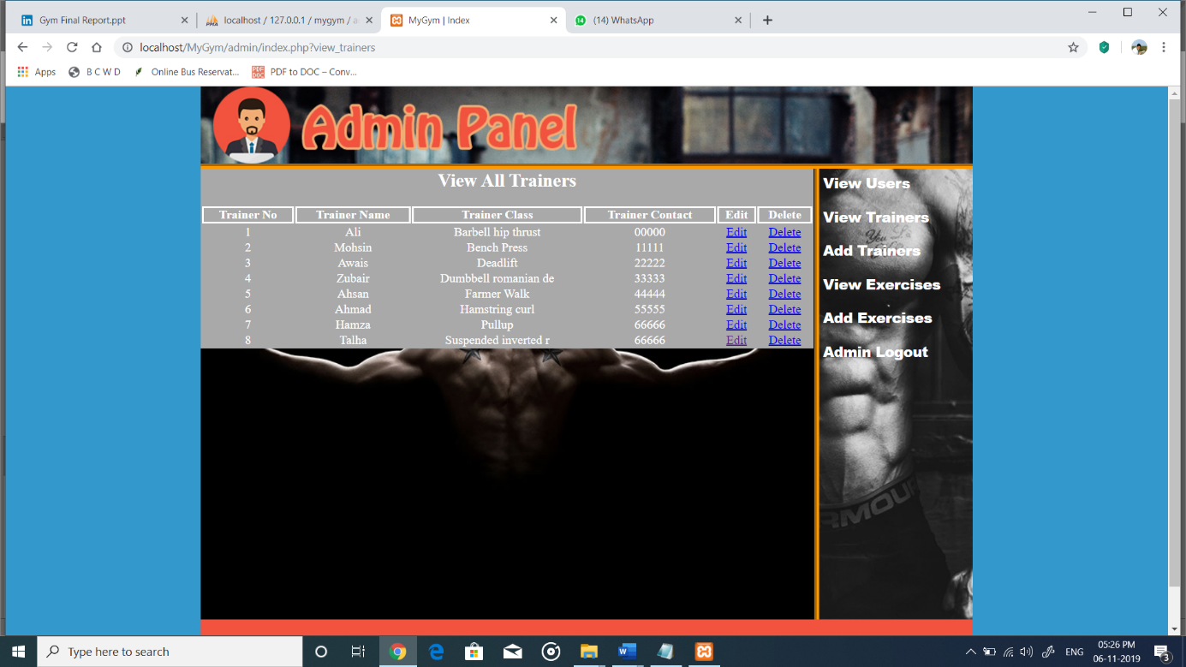

This is a screenshot of the view trainer. In this we get to see the information of the trainers who trains in the gym. For the entity view trainers there are some attributes that are trainer_no, trainer_name, trainer_class, trainer_contact, edit, delete. This all are use to specify the details of trainer by this we are easy to find the trainers who are there.

**Admin Add New Trainers :**

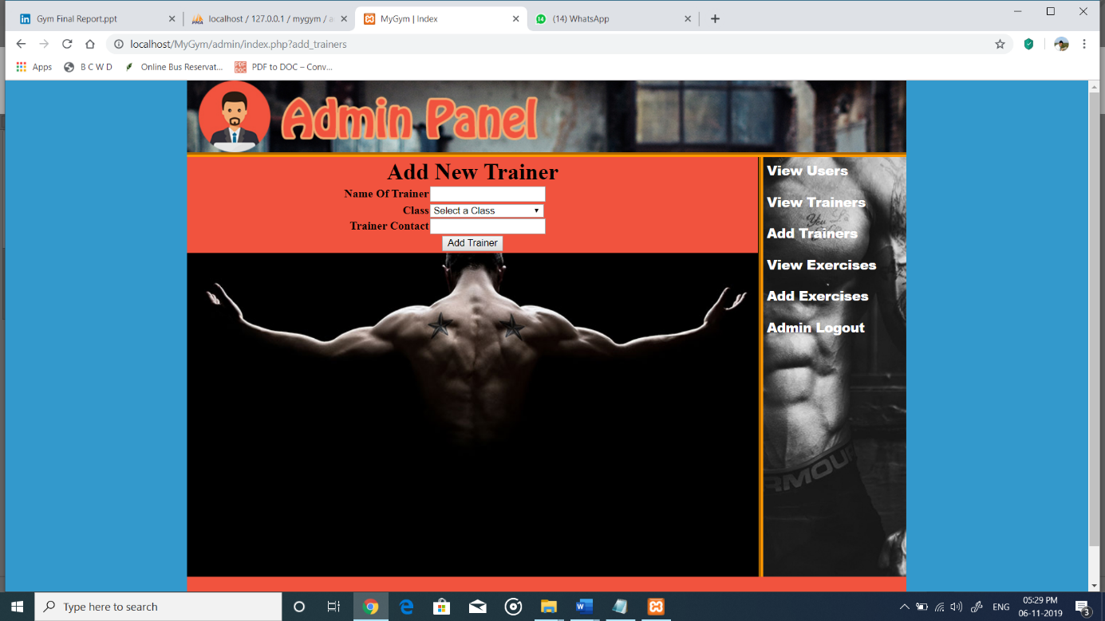

This is a screenshot of the adding new trainer. This is use to add the new trainer in the gym, in this add new trainers entity we have some attributes like name of trainer, class, trainer contact. This all information is use to add new trainer.

**Admin View Exercise :**

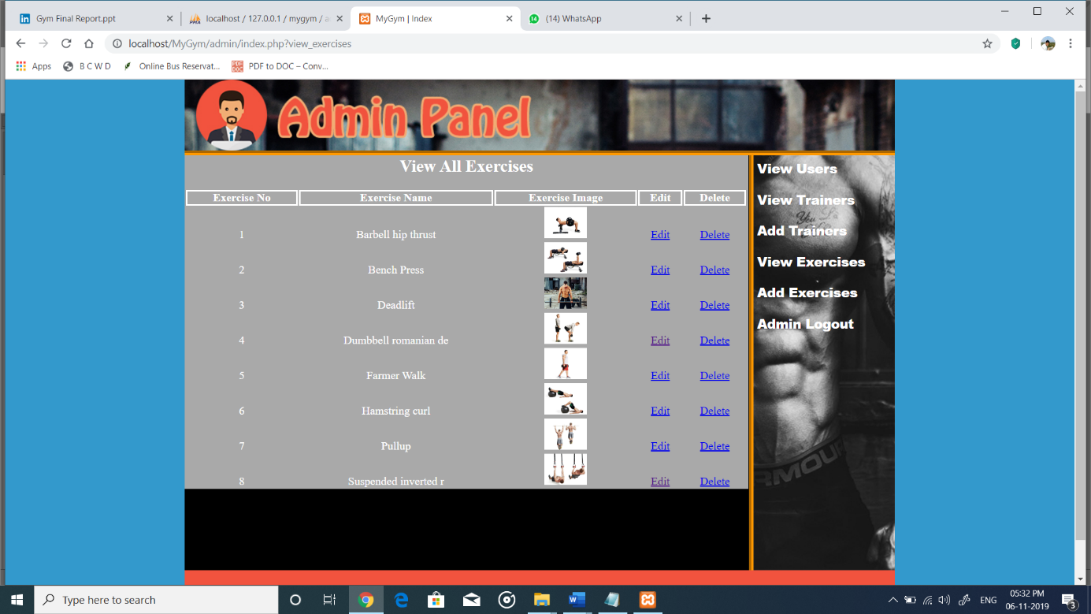

This is the screenshot of the insert exercise this is use to insert the new exercise in the gym. Insert exercises is the entity which has attributes like select user, days, name of exercises, number of sets, exercises image. By this it use to add new exercises for the gym.

**Admin Add Exercise :**

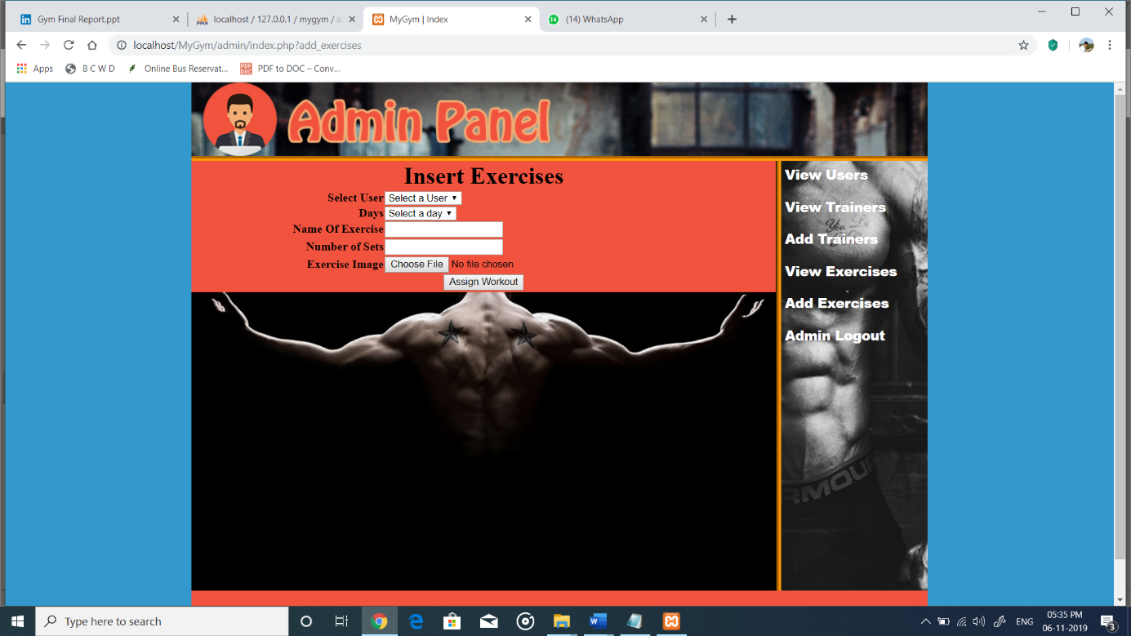

This is a screenshot of the view all exercises. In this we get to see all kind of the exercises performed in the gym for give more information for the users. For the entity view all exercises we have some attributes like exercise_no, exercise_name, exercise_image, edit, delete. This all attributes use to specify the exercises and exercises names.

**User Login Page :**

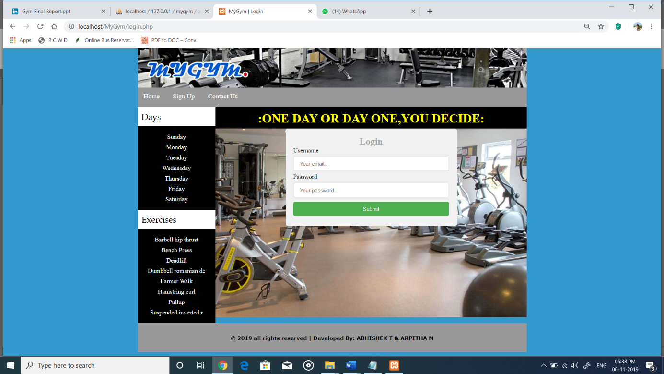

This is a screenshot of the user login page. By this user can login to the gym fill there name and password and click to submit to login for register the new user to gym. This all process will be handled by the admin, only he can has rights to operates this system.

**User Registration Page :**

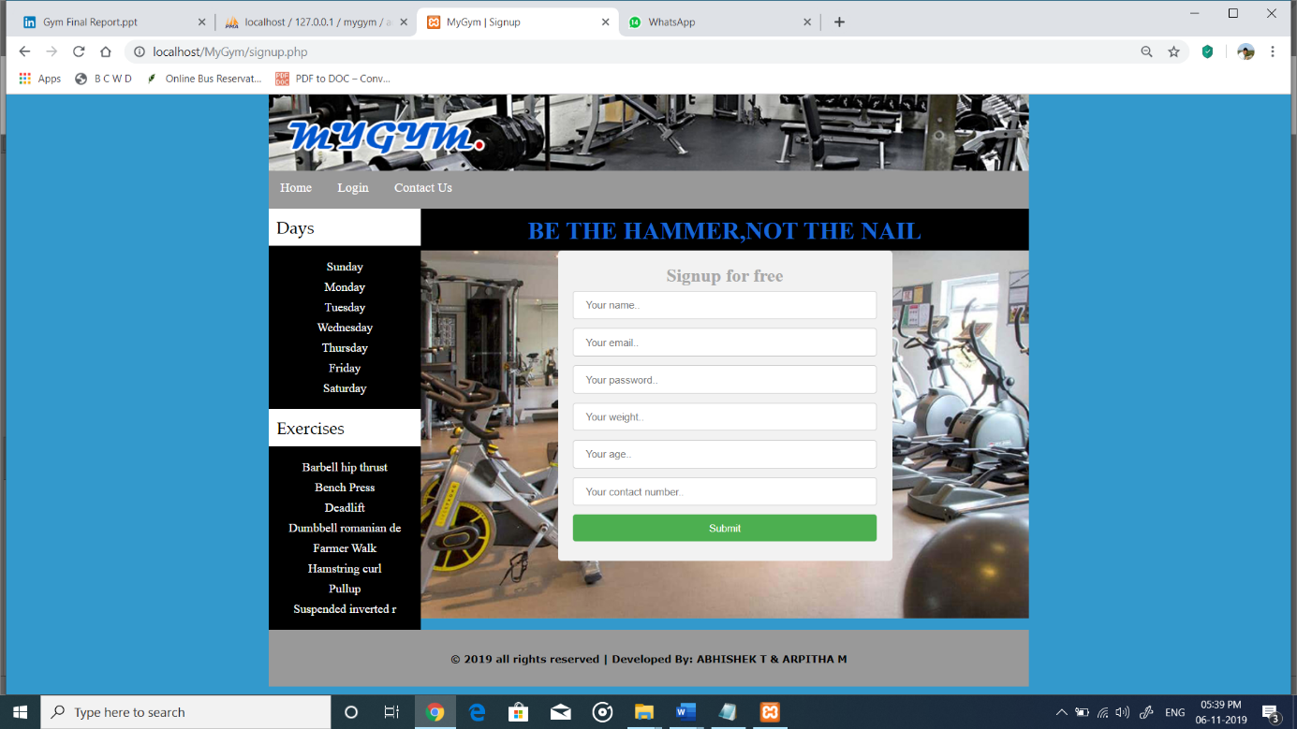

This is a screenshot of the user registration form. This is use to fill the details of the users for registration for the gym, signup is free for users. In that there are some attributes that are your name, your email, your password, your weight, your age, your contact number. By all this details it is very useful for admin to contact with the users.

**Now here are some screenshots of the exercise which will perform in the gym with the photos.**

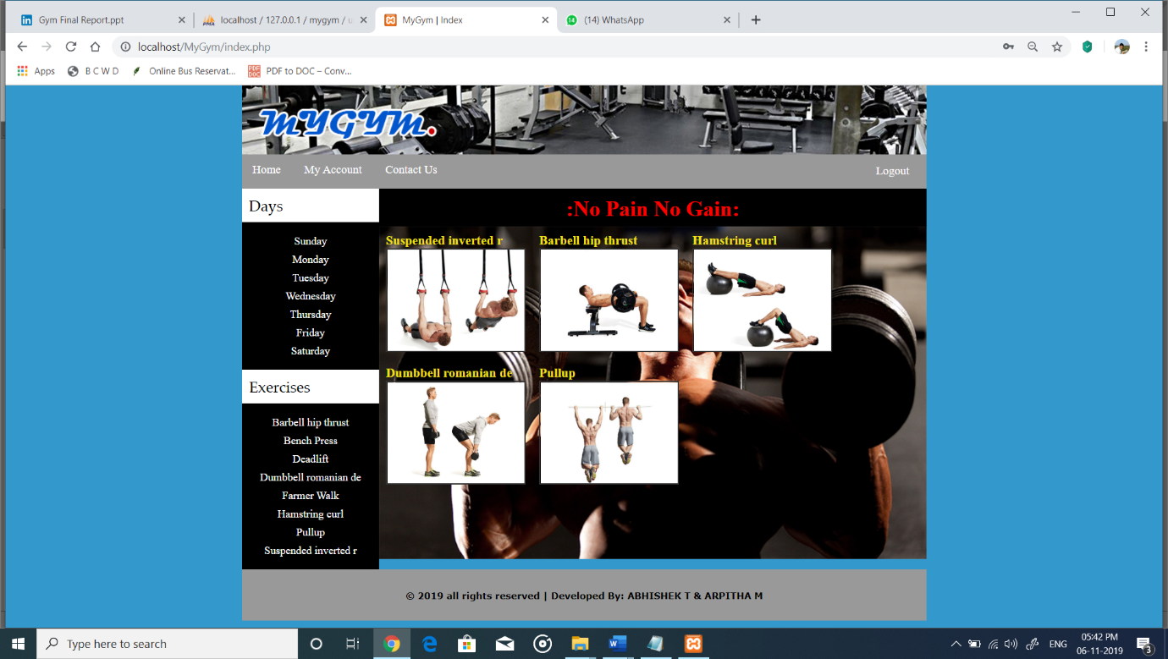

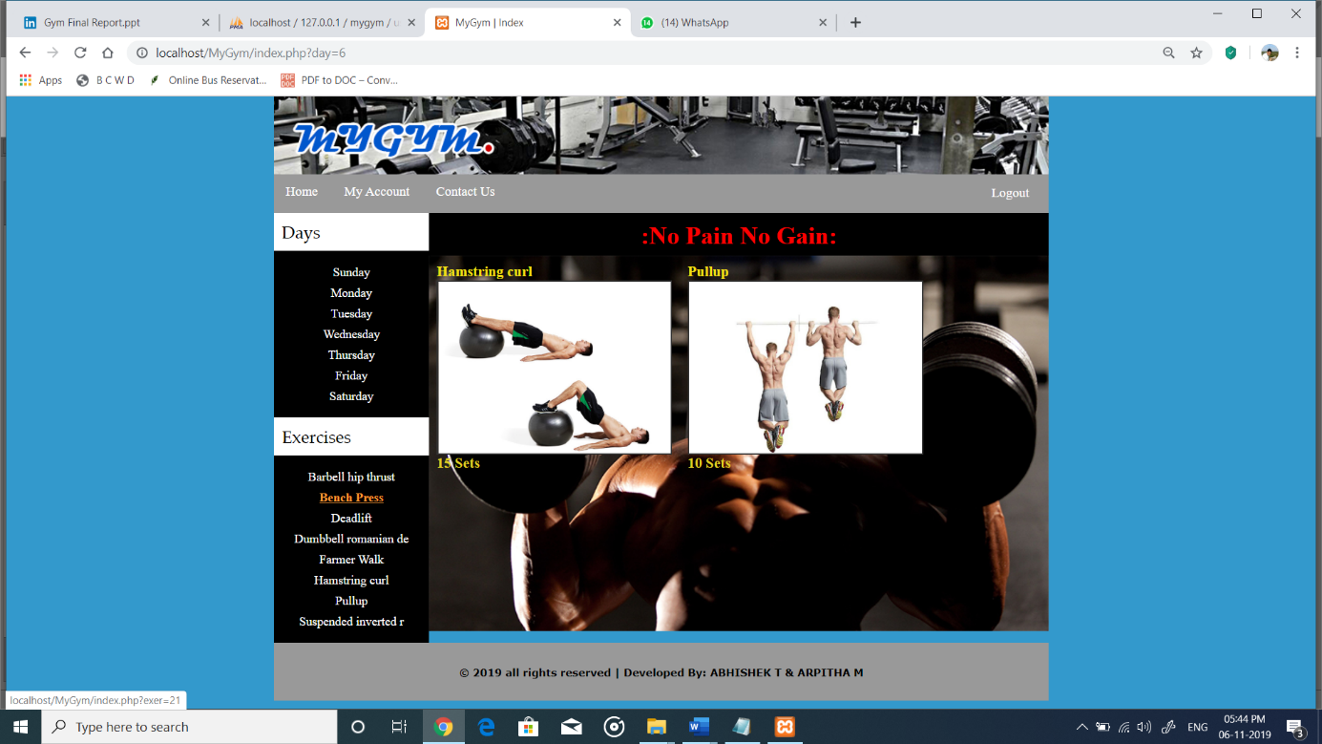

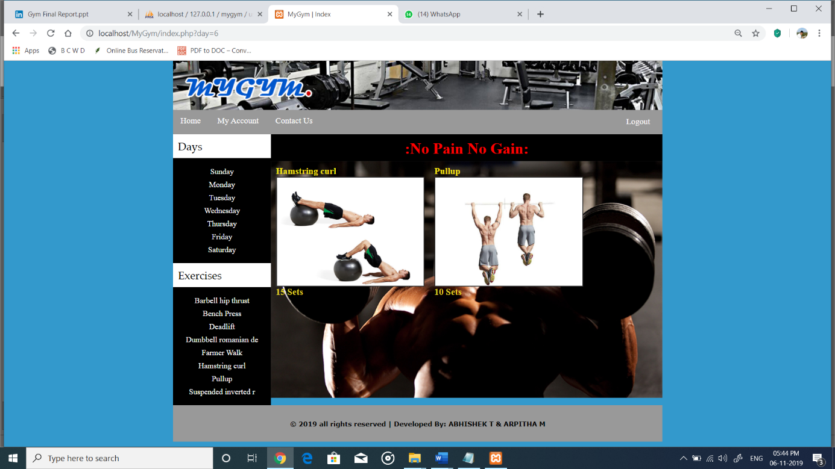

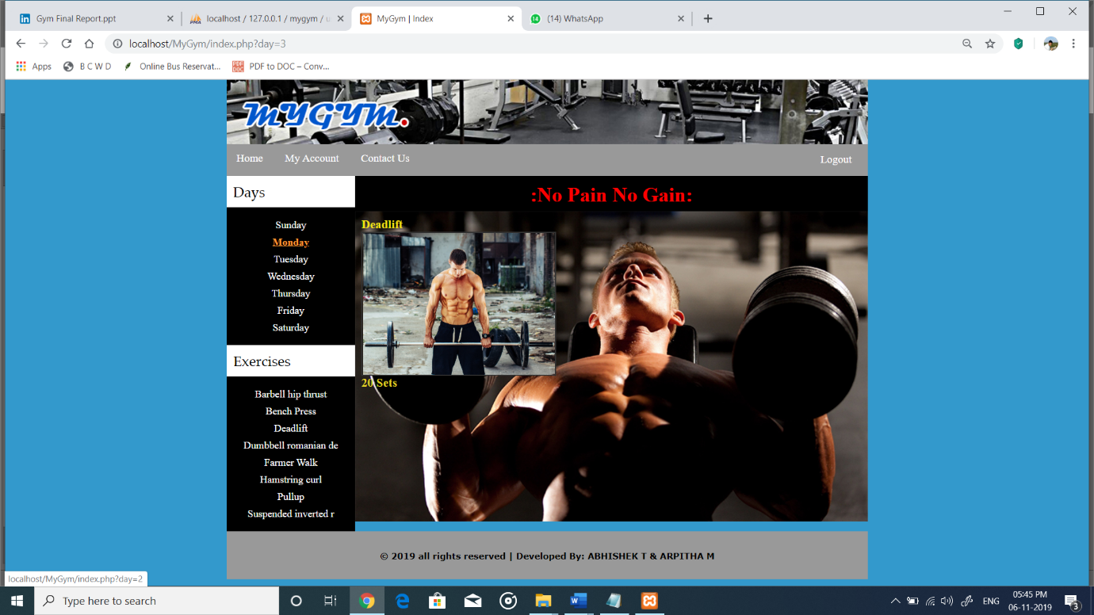

**Chapter 6**

**6.1 Conclusions :**

The “​**GYM MANAGEMENT SYSTEM**​” is successfully designed and developed to fulfilling the necessary requirements, as identified in the requirements analysis phase, such as the system is very much user friendly, form level validation and field level validation are performing very efficiently. The old manual system was suffering from a series of drawbacks. The present project has been developed to meet the aspirations indicated in the modern age.

The gym system works efficiently as gym management system it is robust and will not crush while running in the event of user input error or user misuse. The system could be expanded to cater for large gym. There is no limit to the amount of information that this system can hold.

This system holds information about gym members, employees, equipment and also fitness classes. Information can be removed at any time from the system. This project has proven to be a worthwhile exercise in software development from inception to planning and execution of the code.

**Chapter 7**

**Future enhancement :**

**7.1 Future works**

The project has been developed in a very short period of time and all efforts have been taken so that this project is very efficient in its execution there still exists some scope of improvement in our project. The following lists some of the enhancement that can be added incorporate into the project.

Application of the project can be done more attractively. Database management and all maintenance module can be updated which helps the administrator. More security measures can be taken.

There are also few features which can be integrated with this system to make it more flexible. Below list shows the future points to be consider:

* Real-time Chat BOT option for members and trainer, so that members can directly enquiry theirs trainer on any time through the Chat BOT.
* Automated Fitness suggestion by enquiring the condition of the health.
* Real time Claim Processing Bot.
* Video conversation option for trainers and members.
* Online payment through face recognition.
* Barcode generation for membership card and using this, members can take entry to Gym.
* Finger print matching for taking entry to gym.

**Chapter 8**

**BIBILOGRAPHY**

**SITE**

1. [www.wikipedia.com](http://www.wikipedia.com/)
2. [www.tutorialspoint.com](http://www.tutorialspoint.com/)
3. <https://www.apachefriends.org/download.html>
4. <http://www.slideshare.net/jagaarj/database-design-normalization>

**BOOKS**

1. “Database management systems” Ramakrishna R. Mcgraw-Hill (2014)
2. “Fundamentals of Database Systems” Shamkant B. Navathe , Pearson (2017)